Headache and Neck Pain, Challenges, Pitfalls, and Opportunities
Organized by: Georgian Association of Medical Specialties (GAMS)
Location: Borjomi, Georgia
Plan to submit the application for this event to EACCME(UEMS) -CME Accreditation: 12 European CME Credits (ECMEC©)

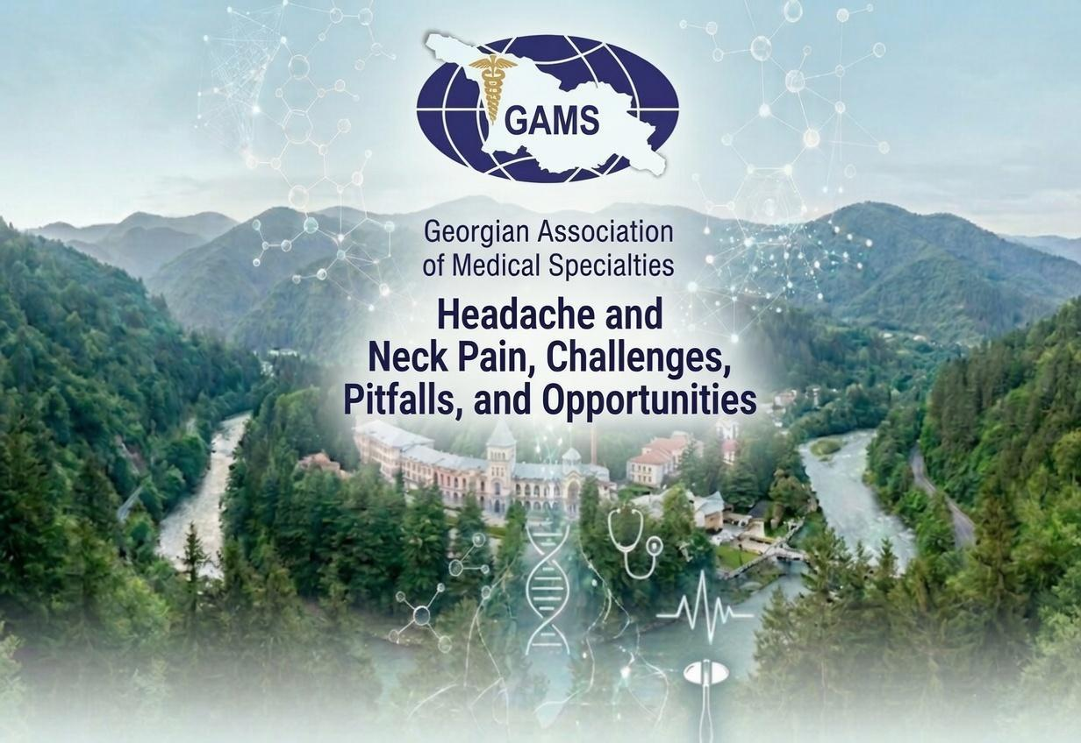

GAMS XI International Regional Conference marks an important milestone for GAMS. This year is the 20th anniversary of our organization’s affiliation with UEMS. GAMS has grown into a leading platform for dynamic and engaging debates on the most pressing and challenging issues in medicine. This is not only a celebration of the past, but also a reaffirmation of our commitment to advancing knowledge, skills, and competencies through open dialogue and critical thinking.
GAMS Board Executives
Prof. George Chakhava – Organizing Committee Chair
Prof. Maia Beridze – Organizing Committee Co-Chair
Organizing Committee:
Prof. M. Okujava, Assoc. Prof. I.Nadareishvili, Dr M.Demuria, G. Matchavariani, M.D., M.P.H., I. Apshinashvili, M.D.
Scientific Committee :
- Professor Piero Barbanti, Head of the Headache and Pain Unit, Professor of Neurology and Sport at the San Raffaele Telematic University in Rome, President of the Italian Association for the Fight against Headaches (AIC), and President-Elect of the Italian Neurological Association for Headache Research (ANIRCEF). Istituto di Ricovero e Cura a Carattere Scientifico [IRCCS] San Raffaele Pisana, Rome, Italy
- Professor Jacek Losy, Department of Clinical Neuroimmunology, Poznan University of Medical Sciences, Poznań, Poland
- Professor Tanya Gurevich, FEAN, PF Center of Excellence, Parkinson’s Neuroautonomic Service, Israeli Huntington’s Disease Centre, and Huntington Study Group, Neurological Institute, Tel Aviv Sourasky Medical Center; Sackler School of Medicine & Sagol School of Neuroscience, Tel Aviv University, Israel
- Professor George Chakhava, D. Tvildiani Medical University, Jo Ann University Hospital, D.Tatisvili Health Center, UEMS Board Neurology, Tbilisi, Georgia
- Professor Serefnur Ozturk, Former President of the Turkish Neurological Society; Secretary of the Union Européenne des Médecins Spécialistes [UEMS] Section and Board of Neurology; Department of Neurology, Selcuk University Faculty of Medicine, Konya, Turkey
- Professor Sadagat Huseynova, Department of Neurology and Medical Genetics, Azerbaijan Medical University, Baku, Azerbaijan
- Professor Maia Beridze, Tbilisi State Medical University (TSMU), UEMS Board Neurology, Tbilisi, Georgia
- Professor Nana Kvirkvelia, Petre Sarajishvili Institute of Neurology, Georgia, Ivane Javakhishvili Tbilisi State University, President of the Georgian Association of Neuromuscular disorders & Electromyography (GANE), Tbilisi, Georgia
- Professor Elene Nebadze, Petre Sarajishvili Institute of Neurology, Member of the Georgian Association of Neuromuscular disorders & Electromyography (GANE), Tbilisi, Georgia
- Professor Davit Zurabashvili, Institute for Mental Health and Addiction Prevention; Tbilisi State University, Georgian Society of Psychosomatic Medicine, Tbilisi, Georgia
- Professor Nino Okribelashvili, Institute for Mental Health and Addiction Prevention; Tbilisi State University, Society of Georgian Psychiatrists, Tbilisi, Georgia
- Professor Nana Tatishvili, President of the Association of Georgian Child Neurology and Neurosurgery; David Tvildiani Medical University, Institute of Neurology and Neuropsychology, Tbilisi, Georgia
- Professor Marina Janelidze, Department of Neurology, Tbilisi State Medical University, Tbilisi, S.Khechinashvili University Hospital, Board of Neurology GAMS, Tbilisi, Georgia
- Professor Wolfgang Grisold, Immediate Past President of the World Federation of Neurology [WFN]; Ludwig Boltzmann Institute, Vienna, Austria
- Professor Tamar Akhvlediani, NeoLab Clinic, Department of Neurology and Psychiatry of the Georgian American University (GAU), Tbilisi, Georgia
- Professor Mikheil Okujava, Todua Clinic, Ilia State University, Georgian Society of Radiology, Georgian Association of Neuroradiology, UEMS Board of Radiology, Tbilisi, Georgia
- Professor Mariam Kekenadze, Tbilisi State Medical University, Tbilisi, Georgia
- Professor Shorena Vashadze, Batumi State University, Batumi, Georgia
- Professor Sophio Mikiashvili, Caucasus Medical Centre, Aversi Clinic, American Hospital of Tbilisi, Radiology Board GAMS, Tbilisi, Georgia
- Professor Olegs Sabelnikovs, Department of Clinical Skills and Medical Technology, Academic Staff, Department of Anesthesiology and Intensive Care, European Board of Anesthesiology, Riga, Latvia
- Professor Nikoloz Sainishvili, Caucasus Medical Centre, UEMS Board of Radiology, Georgia
- Professor Mirza Khinikadze, Caucasus Medical Centre, “New Vision” University, UEMS Board of Neurosurgery, Tbilisi, Georgia
GAMS Scientific Program: Headache and Neck Pain, Challenges, Pitfalls, and Opportunities
Organized by: Georgian Association of Medical Specialties (GAMS)
Location: Borjomi, Georgia, Hotel Borjomi Likani, 16 Meskheti str. Borjomi, Georgia 1200
Date: 9-10 October, 2026

Headache and Neck Pain: Challenges, Pitfalls and Opportunities

DAY 1
- 15:00 - 15:30 | Registration and Welcome Coffee
- Moderators: Olegs Sabelnikovs/George Chakhava 15:30 - 17:30 | Session 1: Critical Care and Cranial Pain Syndromes
  - 15:30 | Professor Olegs Sabelnikovs (President of the Union Européenne des Médecins Spécialistes [UEMS] European Board of Anesthesiology; Head of the Department of Anaesthesiology, Intensive Care and Clinical Simulation, Rīga Stradiņš University, Latvia) – Headache as a Warning Sign: Recognizing Critical Conditions in Anesthesiology and Intensive Care
  - 15:50 | Professor Wolfgang Grisold (Immediate Past President of the World Federation of Neurology [WFN]; Ludwig Boltzmann Institute, Vienna, Austria) – Cranial Nerves: Painful Syndromes
  - 16:10 | Professor Tamar Akhvlediani (NeoLab Clinic, Head Department of Neurology and Psychiatry of the Georgian American University [GAU], Tbilisi, Georgia) – Postherpetic Neuralgia: Why Does Pain Persist After the Rash Has Healed and Can It Be Prevented?
- 16:30 - 17:30 | Interactive Panel Discussion I: DAY 1
- Moderators: Maia Beridze/ Nana Tatishvili 17:30 - 19:30 | Session 2: Challenges of Pediatric and Adult Headaches
  - 17:30 | Dr. Aygun Musayeva, Dr. Sarkhan Amirgulyev (Azerbaijan Medical University / Department of Neurology and Neurophysiology, Azerbaijan State Institute of Advanced Training of Physicians, Baku, Azerbaijan) – Prevalence and Clinical Spectrum of Headache Disorders Among School-Aged Children and Adolescents in Azerbaijan
  - 17:50 | Professor Nana Tatishvili (President of the Association of Georgian Child Neurology and Neurosurgery; Professor at David Tvildiani Medical University; Institute of Neurology and Neuropsychology, Tbilisi, Georgia) – Prevalence of headache disorders among children and adolescents in Georgia: cross-sectional schools-based study
  - 18:10 | Professor George Chakhava, Dr. Miranda Demuria, Giorgi Matchavariani, MD (President GAMS, Associate Professor at David Tvildiani Medical University, Neurology Department, Jo Ann University Hospital / GAMS Neurology Section Secretary, Neurology Department, Jo Ann University Hospital / resident-neurologist, GAMS Secretary, Caucasus Medical Centre, Tbilisi, Georgia) – Drug-Overuse Headache: Pitfalls and Challenges
  - 18:30 - 18:50 | Prof. Shorena Vashadze, Dr. Mariam Kekenadze (Batumi Shota Rustaveli University / Tbilisi State Medical University, ALS Association Georgia) – Pain in Amyotrophic Lateral Sclerosis: An Underrecognized Symptom
- 18:50 - 19:50 | Interactive Panel Discussion II: DAY 1

DAY 2
- Moderators: Jacek Losy/ Marina Janelidze 09:00 - 11:20 | Session 3: Systemic, Environmental and Psychiatric Comorbidities
  - 09:00 | Professor Jacek Losy (Department of Clinical Neuroimmunology, Poznan University of Medical Sciences, Poznań, Poland) – Headache in Multiple Sclerosis: Clinical Types, Causes, and Management
  - 09:20 | Professor Serefnur Ozturk (Former President of the Turkish Neurological Society; Secretary of the Union Européenne des Médecins Spécialistes [UEMS] Section and Board of Neurology; Department of Neurology, Selcuk University Faculty of Medicine, Konya, Turkey) – Headache and the Environment
  - 09:40 | Professor Davit Zurabashvili, Professor Nino Okribelashvili (Institute of Mental Health and Addiction Prevention; Georgian Society for Psychosomatic Medicine / President of the Society of Georgian Psychiatrists, Department of Psychiatry and Medical Psychology, Ivane Javakhishvili Tbilisi State University, Tbilisi, Georgia) – Post-Traumatic Stress Disorder [PTSD], Central Sensitization, and Chronic Headache: What should Psychiatrist Recognize
  - 10:00 | Professor Sadagat Huseynova (Department of Neurology and Medical Genetics, Azerbaijan Medical University, Baku, Azerbaijan) – Migraine and Psychiatric Comorbidity
- 10:20 - 11:20 | Interactive Panel Discussion I: DAY 2
- 11:20 - 12:00 | Morning Coffee Break
- Moderators: Piero Barbanti/Alexandre Tsiskaridze 12:00 - 14:00 | Session 4: Primary Headaches and Targeted Therapies
  - 12:00 | Professor Piero Barbanti (Head of the Headache and Pain Unit, the San Raffaele Telematic University in Rome, President of the Italian Association for the Fight against Headaches (AIC), and President-Elect of the Italian Neurological Association for Headache Research (ANIRCEF), Istituto di Ricovero & Cura a Carattere Scientifico [IRCCS] San Raffaele Pisana, Rome, Italy) – Frontiers and Pitfalls of Primary Headache
  - 12:20 | Professor Tanya Gurevich (Fellow of the European Academy of Neurology; Director of the Movement Disorders Unit, Director of the Parkinson's and Neuroautonomic Service, American Parkinson Disease Association [APDA] Center of Excellence, Multiple System Atrophy [MSA] Center of Excellence, Israeli Huntington's Disease Center, Neurological Institute, Tel Aviv Sourasky Medical Center; Professor of Clinical Neurology, School of Medicine and Sagol School of Neuroscience, Tel Aviv University, Israel) – Botulinum Toxin as a Targeted Therapy for Headache and Neck Pain
  - 12:40 | Professor Natela Okujava (Associate Professor of the Neurology Department, Head of the Epilepsy Department at Simon Khechinashvili University Hospital, Tbilisi, Georgia) – Migraine and Epilepsy: Coexistence or Connection?
- 13:00 - 14:00 | Interactive Panel Discussion II: DAY 2
- 14:00 - 15:00 | Lunch Break

- Moderators: Tanya Gurevich/Mikheil Okujava/Nikoloz Sainishvili 15:00 - 18:20 | Session 5: Neuroradiology, Vascular Pathology and Neurosurgery
(From Red Flags to Rare Syndromes: Navigating Diagnostic Dilemmas)
  - 15:00 | Professor Mikheil Okujava (Doctor of Medicine, Doctor of Science; Head of Neuroradiology and Neuroscience at Todua Clinic; Professor, School of Natural Sciences and Medicine, Ilia State University; GAMS Representative in the Union Européenne des Médecins Spécialistes [UEMS] Radiology Board; President of the Georgian Society of Neuroradiology; Vice-President of the Georgian Association of Radiologists; Corresponding Member of the Georgian National Academy of Sciences, Tbilisi, Georgia) – Appropriate Use of Imaging in Patients with Headache
  - 15:20 | Associated Professor Sophio Mikiashvili (Doctor of Medicine, David Aghmashenebeli University of Georgia [SDASU]; Caucasus Medical Centre; GAMS Radiology Section, Tbilisi, Georgia) – Magnetic Resonance Imaging [MRI] Findings in Neurogenic Facial Pain: Case-Based Reviews
  - 15:40 | Professor Maia Beridze (Head of the Neurology Department, Tbilisi State Medical University; GAMS Representative in the Union Européenne des Médecins Spécialistes [UEMS] Board of Neurology, Tbilisi, Georgia) – Certain Genetically Determined Vascular Diseases and Associated Headaches
  - 16:00 | Professor Alexandre Tsiskaridze (President of the Stroke Society of Georgia; Head of the Neurology Department, Ivane Javakhishvili Tbilisi State University; Head of the Neurology Department, Pineo Medical Ecosystem, Tbilisi, Georgia) – Stroke and Headache
  - 16:20 | Associate Professor Marika Alfaidze (President of the Georgian Society of Cerebral Hemodynamics and Neurosonology; Department of Neurology, The First University Clinic of Tbilisi State Medical University, Tbilisi, Georgia) – Headaches of Vascular Origin
  - 16:40 | Professor Mirza Khinikadze (Vice Rector of New Vision University; Expert Neurosurgeon at the Ministry of Internally Displaced Persons from the Occupied Territories, Labor, Health and Social Affairs of Georgia; Member of the Professional Development Council; Department of Neurosurgery and Interventional Neuroradiology, Caucasus Medical Centre, GAMS Representative in the Union Européenne des Médecins Spécialistes [UEMS] Board of Neurosurgery, Tbilisi, Georgia) – Endovascular Treatment of Ischemic Stroke: Modern Aspects
  - 17:00 | Elene Nebadze, Nana Kvirkvelia, Mariam Kekenadze, Rusudan Nikolaishvili, Maia Jibladze, Ekaterine Sheshaberidze (Iv.Javakhishvili State University, Petre Sarajishvili Institute of Neurology, Tbilisi State Medical University, Grigol Robakidze University, Multiprofile Medical Center-Healthycore, Eka Sheshaberidze Health and Rehabilitation Center, Tbilisi, Georgia) – Modern Principles of Upper Crossed Syndrome Management
  - 17:20 | Dr. Ana Lomtadze (Department of Radiology, Saint Michael Archangel Clinical Hospital, Tbilisi, Georgia) – C1–C2 Cervical Vertebrae Fractures: Radiological Diagnostics, Specifics, and Significance in Preoperative, Intraoperative, and Postoperative Periods
- 17:40 - 18:40 | Interactive Closing Panel Discussion: The Neurology-Neurosurgery Interface: Advanced Strategies in Secondary Headaches, Spine, and Vascular Pathologies
- 18:40 | Closing Remarks and Farewell

