Georgian Association of Medical Specialties
(GAMS)
VIII International Conference
“Neurochallenges 2023 in the Era of Evidence-Based and Personalized Medicine”
September 16-17, 2023

Chakvi, Adjara, Georgia
-------------------------------------------------------------------------------------

Organized by

Georgian Association of Medical Specialties
in collaboration with
David Tvildiani Medical University and Batumi Shota Rustaveli State University, with participation Ilia State University

Agenda

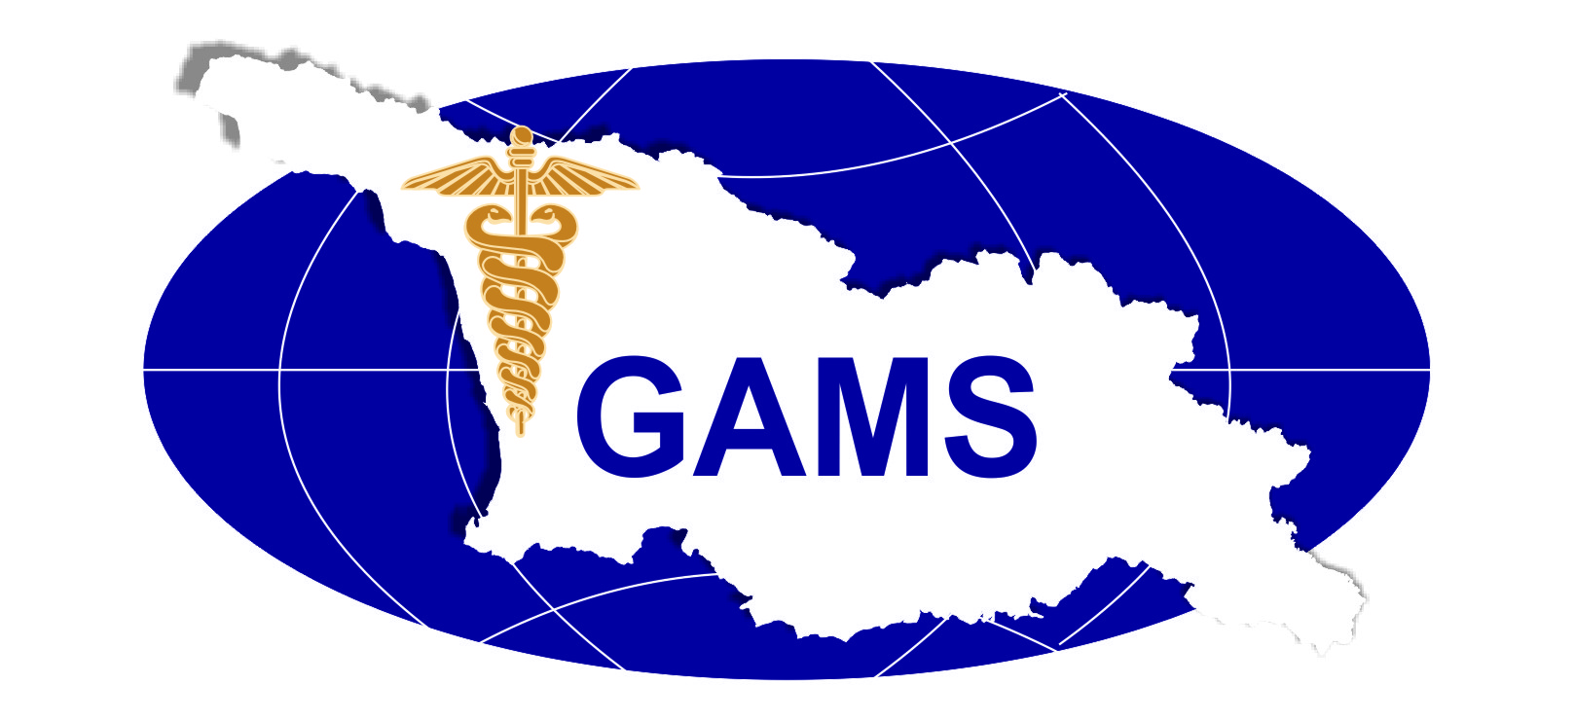
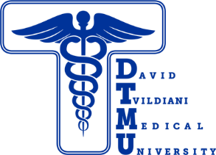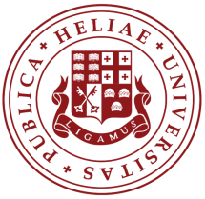

Prof. George Chakhava – Organizing Committee Chair

Prof.Amos Korczyn – Organizing Committee Co-Chair

Prof. Maya Beridze – Organizing Committee Co-Chair

Prof. irakli Sulakvelidze -Organizing Committee Co-Chair

Organizing Committee: Prof. Mikhael Okujava, prof. Nino Tabagari, Miranda Demuria MD, prof. Shorena Vashadze, Mariam KekenadzeMD

Secretary: M.Demuria MD

Scientific Faculty:
Irakli Sulakvelidze, Seattle, USA
Amos Korczyn Tel Aviv Israel
George Chakhava Tbilisi, Georgia
Marina Janelidze Tbilisi, Georgia
Maya Beridze Tbilisi, Georgia
Miguel J A Láinez Valensia, Spain
Mirza Khinikadze Tbilisi, Georgia
Alexander Tsiskaridze Tbilisi, Georgia
Zurab Nadareishvili Vashington DC, USA
Serefnur Ozturk Conya, Turkey
Philip Bath Nottingham , UK
Nikola Sprigg Nottingham , UK
Mikheil Okujava Tbilisi, Georgia
Revaz Solomonia Tbilisi, Georgia
Nana Kvirkvelia Tbilisi, Georgia
Madona Sekhniashvili Tbilisi, Georgia
Sophio Mikiashvili Tbilisi, Georgia
Nikoloz Sainishvili Tbilisi, Georgia
Zaal Kokaia Lund, Sweden
Eka Chkonia Tbilisi, Georgia
George Pkhakadze Paris, France
Tatyana Gurevich Tel Aviv, Israel
Sofia Kasradze Tbilisi, Georgia
Ia Rukhadze Tbilisi, Georgia
Shorena Vashadze Batumi, Georgia
Tamuna Goderidze Tbilisi, Georgia

"if you think that education is expensive you should consider ignorance"
-Socrates
The Conference will be accredited by UEMS EACCME
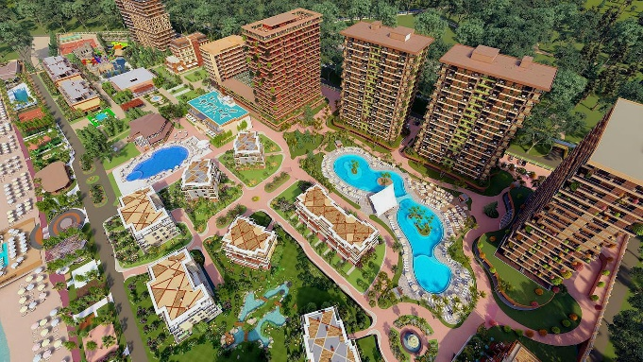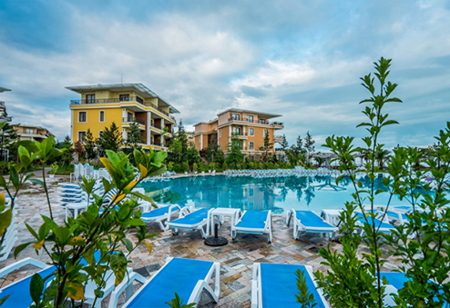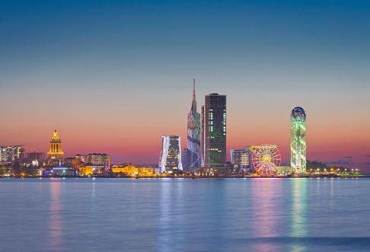
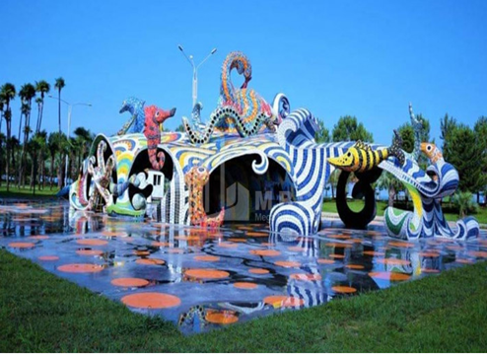

Dreamland Oasis Hotel, Chakvi, Adjara Georgia 16-17.09.2023

Explore Ajara
Batumi

Dreamland Oasis Hotel offering: in the case of preliminary booking significant discount( promo code: GAMS 2023 Neurochallenges) will be provided for the conference registered participants
The organizing committee of the conference hereby invites you to visit the botanical garden of Batumi, before attending the opening ceremony of the conference. Subsequently, it is noteworthy, that the closing ceremony of the conference will be accompanied by folk performances.

Participants of the conference will also have an opportunity to visit Batumi archeological museum, which stores various interesting artifacts that are well-known worldwide.

Furthermore, participants of the conference will have an opportunity to witness the beauties of the pearl of the Black Sea -Batumi, its charming boulevard, and have a taste of well-known Georgian cuisine.

Lastly, we hope that you will enjoy your stay here and get acquainted with the Georgian culture and its rich history.

09:00- 09:30 | Registration
9:30-10:00 | Opening  G.Chakhava President GAMS Amos Korczyn President CONy  L.Tvildiani Rector of D.Tvildiani Medical University  M. Khalvashi Rector Batumi Shota Rustaveli State University  Rapresentatives of Government of Autonomous Republic Adjara, Ministry of Health, Batumi City Hall  Prof. Sh.Vashadze Regional Representative-ambassador  of GAMS in Adjara
 | 16.09.2023 Session 1
10:00-  10:20  10:20-  11:40  11:40-  11:20  11:20-11:40  11:40-12:00  12:00-12:20  12:20-  12:40  12:40-13:00 | Neural mechanisms of mindfulness meditation in pain modulation  Irakli Soulakvelidze, Clinical prof. University of Washington Anaesthesiology and Pain Medicine, Attending Physician: Centre for Pain Relief, UWMC Seattle Washington USA  Representative of GAMS in Multidisciplinary Joint Committee in Pain Medicine (MJCPM) UEMS  Neuromodulation in headache  Miguel J A Láinez prof. Chairman of the Department of Neurology at the Hospital Clínico Universitario and Professor of Neurology at the Catholic University of Valencia in Valencia, Spain. Ordinary Member of the Real Academia de Medicina de la Comunidad Valenciana. President of the Sociedad Española de Neurología  Is Alzheimer's disease a disease?  Amos Korczyn Prof. Ex-chairman of the Department of Neurology at the Tel-Aviv Medical Center, Sieratzki Chair of Neurology at Tel-Aviv University. President of CONy-the International World Congress on Controversies in Neurology.  Chairman of the Scientific Medical Board of the Israeli Alzheimer's disease Tel Aviv Tel Aviv Israel Association (EMDA), member of the SAB of Alzheimer Disease International (ADI) Tel Aviv Israel  Challenges in Dementia and MS Management in Georgia-actual role of BTK inhibitors in the nearest future.  George Chakhava, Assoc.Prof. D.Tvildiani Medical University, GAMS Representative in UEMS Board Neurology; Miranda Demuria MD D.Tatishvili Health Center,Multiprofile Clinic Consilium Medulla, Representative of GAMS in UEMS Board of Neurology , Tbilisi, Georgia  “Neuroinflammation –Concept’s Evoluation”  Marina Janelidze, prof.,Secretary General, Georgian Union of Neurologists, Chairperson Department of Neurology Tbilisi State Medical University, Head of Department Neurology, S.Khechinashvili University Hospital Tbilisi, Georgia  “Neurotuberculosis is still a challenge in the era of modern diagnostics and treatment" Maia Beridze, Prof. Head of Neurology Department TSMU, Representative of GAMS in UEMS Board of Neurology , Tbilisi, Georgia  Diagnostic tools in Myopathies  Stephan Zierz, Prof. Martin Luther University  Halle-Wittenberg, MLU Clinic for Neurology, Head of Department Neurology,  Representative of Germany in UEMS Board Neurology, Germany  Discussion
13:00-  14:00 | Lunch

 | Session 2
14:00-14:20  14:20-  14:40  14:40-  15:00  15:00-  15:30  15:30-  15:50  15:50-  16:10  16:10-  16:30  16:30-  16:50  16:50-17:50  20:00 | Stroke prevention in patients with intracranial atherosclerosis  Alexander Tsiskaridze, Professor, Department of Neurology, Ivane Javakhishvili Tbilisi State University, Pineo Medical Ecosystem, President of Georgian Stroke Society, Tbilisi, Georgia  Is Post-stroke Cognitive Impairment Biomarker of Recurrent Stroke?  Zurab Nadareishvili, Assoc.Prof.MD, PhD; Department of Neurology, The George Washington University,Washington, DC, and Comprehensive Stroke Center, VHC Health, Arlington Virginia  Environment and Stroke-a preventable risk factor  Serefnur Ozturk, M.D., FEAN, Prof.Neurology and head of the neurology department and stroke center of the Selcuk University, Faculty of Medicine in Konya, Turkey. Former president of The Turkish Neurological Society and member of many national and international committees. UEMS Representative of Turkey, member of UEMS/Neurology Section, Board Examination Committee Konya, Turkey.  From bench to bed - human cortical tissue as an ex vivo translational model  for cell therapy in stroke  Kokaia Zaal, PhD, MAE Prof. of Experimental Medical Research  Head of the Laboratory of Stem Cells & Restorative Neurology  Lund University Hospital, Lund, Sweden  Management of post stroke dysphagia and assessment of pharyngeal electrical stimulation in the PhEAST trial  Philip Bath, Prof. of Stroke Medicine, Chair and Head of the Division of Clinical Neuroscience at the University of Nottingham, UK  Modern Aspects of Surgery for Stroke  Mirza Khinikadze , Prof. The Chairman of the Board of Georgian Association of Neurosurgeons. Head of New Vision University Hospital’s Neurosurgery and Neurology Direction.  Board member of Professional Developmental Direction of Ministry of Health, Labor and Social Affairs of Georgia Tbilisi, Georgia  Discussion  Coffe Break  Satellite Symposia  Gala Dinner
 | 17.09.2023 Session 3
10:00-10.20  10:20-10.40  10:40-  11:00  11:00-11:20  11:20-11:40  11:40-12:00  12:00-12:20  12:20-12:40  12:40-13:40 | Study of Glymphatic system using MRI  Mikheil Okujava, MD, PhD, DSc  Head of Neuroradiology and Neuroscience, Todua Clinic  Prof. Ilia State University, School of Natural Sciences and Medicine  Vice-President of Georgian Society of Radiology Representative of GAMS in UEMS Board of Radiology Tbilisi, Georgia  Animal Imaging. Technical, Development and Ethical issues. Own Experience.  Nikoloz Sainishvili Radiology Group Leader Evex Medical Corporation, CMC - Caucasus Medical Centre, Representative of GAMS in UEMS Board of Radiology Tbilisi, Georgia  Inhibition of Epileptogenesis by Myo-inositol; behavioral, electrophysiological, morphological and molecular studies  Revaz Solomonia prof. Director, G.Gamkrelidze, L.Tsverava, M.Kandashvili, L.Kharkhelauri, E.Lepsveridze Institute of Chemical Biology, Ilia State University and Iv.Beritashvili Centre of Experimental Biomedicine,  Member of Laboratory Medicine Section of GAMS Tbilisi, Georgia  Scull Base Endosurgery  Malkhaz Kintsurashvili MD Representative of GAMS in UEMS Board of Neurosurgery Prof. Edisher Magalashvili, Tsotne Ckhikvishvili MD Neurosurgery Department American Hospital Tbilisi, Georgia  "Modern principles of diagnosis and management of sporadic inclusion body myositis"  Mariam Kekenadze MD PhD student, Elene Nebadze PhD student, Nana kvirkvelia prof., Iv.Javakhishvili Tbilisi State University, Tbilisi State Medical University  Tbilisi, Georgia  "Rare cases of extraspinal sciatic neuropathy - why do we need MR neurography"  Sophio Mikiashvili, Radiologist, Assoc.Prof. MD Ph.D., CMC - Caucasus Medical Centre, Radiology Section GAMS, Tbilisi, Georgia  "Critical Illness Polyneuromyopathy-the novel diagnostic marker?"  Madona Sekhniashvili MD Neurologist, Head of Neurophysiology Centre  CMC - Caucasus Medical Centre  Representative of GAMS in UEMS Board of Neurophysiology Tbilisi, Georgia  Discussion  Lunch
13:40-14:00  14:00-14:20  14:20-14:50  14:50-15:00  15:00-15:20  15:20-15:40  15:40-16:00  16:00-16:20  16:20-16:40 | Session 4  European Training Requirement ETR in Neurology approved at last UEMS Council in Brussels in collaboration with European Academy of Neurology –Georgian Translation-Challenges  Miranda Demuria MD , George Chakhava Assoc.Prof. , D.Tvildiani Medical University, D.Tatishvili Health Centre, Multiprofile Clinic Consilium Medulla, Maya Beridze Prof. TSMU, Head of Neurology Department, GAMS Representatives in UEMS Board Neurology; Tbilisi, Georgia , Sofo Abashidze Resident Neurology  Hospitals accreditation process as a supportive tool of evidence-based medicine  Giorgi Pkhakadze, Prof., Accreditation Canada Representative in Georgia, Representative of GAMS in UEMS Board of Public Health  Paris, France  Hyperkinetic movement disorders and their management  Tatyana Gurevich, Assoc. Prof.MD, FEAN, Director, Movement Disorders Unit, PF Center of Excellence, Parkinson's & Neuroautonomic Service, Israeli Huntington's Disease Centre, and Huntington Study Group, Neurological Institute, Tel-Aviv Sourasky Medical Center; Sackler School of Medicine & Sagol School of Neuroscience,Tel Aviv University, Israel  A strategic training framework for building research capacity in the  Global Parkinson’s Genetics Program (GP2)  Alex Zirra 2 , Maria Teresa Periñan 1 , Sumit Dey 2 et al.  1. Unidad de Trastornos del Movimiento, Instituto de Biomedicina de Sevilla,  Universidad de Sevilla, Seville, Spain  2. Preventive Neurology Unit, Wolfson Institute of Population Health, Queen  Mary University of London, London, UK  The social phenotype of schizophrenia  Eka Chkonia, Prof. of Psychiatry Tbilisi State Medical University  President of the Society of Georgian Psychiatrists  Representative of GAMS in UEMS Board of Psychiatry Tbilisi, Georgia  “Dark Side of Happinies” Youth Externalizing Disorders and Life Satisfaction  Marina Gegelashvili, Prof. of Psychiatry Ilia State University,Representative of GAMS in UEMS Board of Psychiatry Tbilisi, Georgia  Epileptic Seizure Onset Zone Detection Using the Nonparametric Granger Causality and a New Matrix Spectral Factorization Algorithm  Sofia Kasradze,Prof. Caucasus International University  Director, Institute of Neurology and Neuropsychology (INN),  President , Georgian League Against Epilepsy (GLAE)  Representative of GAMS in UEMS Board of Neurophysiology Tbilisi, Georgia  Uncertainty and Ambiguity in Diagnostics and Management - When Depression and Dementia Coexist  Ia Rukhadze Prof. Acad. N.Kipshidze Central University Clinic, Tbilisi, Georgia  "Indicators of Cognitive Dissonance and Depression in Adjara region, before and after the spread of Covid-19 Infection"  Shorena Vashadze Ass Professor, Batumi Shota rustaveli State University Clinic Medcenter
16:40-17:00  17:00-  17:20  17:20-18:00 | Correlation of Neurological symptoms and Vitamin B12 Levels in COVID-19 Patients  Tamar Goderidze Prof .University of Georgia, Georgian American Family Medicine Centre “Medical House”, Representative of GAMS in UEMS Board of Endocrinology and Leader of GAMS Section Family Medicine, Nino Gulatava MdPh “Megalab” Representative of GAMS in UEMS Board of Laboratory Medicine, Irakli Apshinashvili, Resident in Family Medicine  Discussion  The Farewell -Coffee Break, Vine.

