Georgian Association of Medical Specialties
(GAMS)
VII International Hybrid Conference
“Management of Cognitive Disorders and Pain in the Era of Evidence-Based and Personalized Medicine”
November 19, 2022

Telavi, Kakheti, Georgia
-------------------------------------------------------------------------------------

Organized by

Georgian Association of Medical Specialties
in collaboration with
David Tvildiani Medical University

------------------------------------------------------------------------------------
Agenda

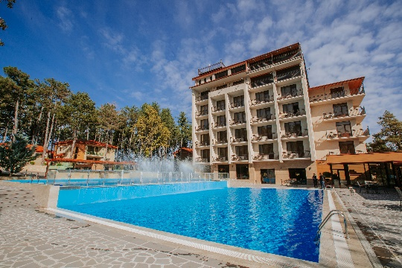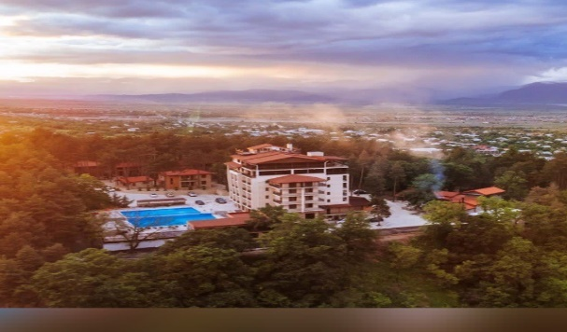
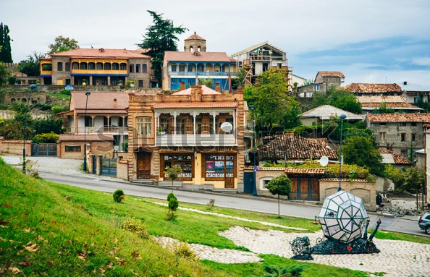

Prof. George Chakhava – Organizing Committee Chair

Prof. Natan Bornstein – Organizing Committee Co-Chair

Prof. Maya Beridze – Organizing Committee Co-Chair

Organizing Committee: Prof. Ilia Nadareishvili, Miranda Demuria MD, Vasil Kobiashvili MD

ZUZUMBO RESORT & SPA Telavi Kakheti Georgia 19.11.2022
09:30- 09:50 | Registration
9:50-10:00 | Opening  G.Chakhava President GAMS  L.Tvildiani Rector of D.Tvildiani Medical University  V. Kobiashvili Head of Neurology Avtantil Kambarashvili Clinic, Regional Representative of GAMS in Kakheti
 | Session 1
10:00-  10:30  10:30-  10:50  10:50-  11:10  11:10-11:30  11:30-11:50  11:50-12:10  12:10-  12:30  12:30-13:00 | “Post-Stroke cognitive decline - The magnitude of the problem and potential solutions", Prof.Natan Bornstein, Bornstein Natan, MD, PhD, Vice President of World Stroke Organization (WSO),Professor of Neurology,Tel Aviv University  Director of the Brain Division, Department of Neurology, Israel Shaare-Zedek Medical Center, Jerusalem, Israel  “Prospective Evaluation of Cognitive Disorders in Post-stroke Population”  Ana Dzagnidze MD PH D, Secretary of Georgian Union of Neurologists, Prof.Marina Janelidze, Head of Department Neurology, S.Khechinashvili University Hospital, Tbilisi, Georgia  “Nanotechnology for early detection and treatment of Alzheimer’s disease” Prof.Jerzy Leszek ,Wroclaw Medical University, Department of Psychiatry, Wroclaw, Poland  “Cluster Headaches Management New Approaches and Clinical Cases”  Assoc.Prof. George Chakhava D.Tvildiani Medical University, GAMS Representative in UEMS Board Neurology; Miranda Demuria MD, Teimuraz Kakubava MD, Multiprofile Clinic Consilium Medulla, Tbilisi, Georgia  "Multimodal analgesia for acute pain treatment in current guidelines and clinical practice" Prof. Dalius JatuŽis, Faculty of Medicine, Institute of Clinical medicine, Clinics of Neurology and Neurosurgery, Vilnius University  Department of Neurology, Vilnius University Hospital Santaros Klinikos  “Diabetic Neuropathy and Pain Phenomenon” Prof. Maia Beridze Head of Department Neurology Tbilisi State Medical University, GAMS Representative in UEMS Board Neurology, Tbilisi, Georgia  “Post COVID-19 Neuropathy Pain" Elene Nebadze Ph.D Fellow, Prof. Nana Kvirkvelia, Tbilisi State University, P. Sarajishvili Institute of Neurology, Tbilisi, Georgia  Discussion
13:00-  14:00 | Lunch

14:00-14:20  14:20-  14:40  14:40-  15:00  15:00-  15:30  15:30-  15:50  16:00-  16:20  16:20  16:40  16:40  17:00 | Session 2  “Non-Steroidal Anti-Inflamatory Drug Use in Elderly "Medical House" – Marika Supatashvili-Znamenski Georgian-American Family Medicine Clinic, D.Tvildiani Medical University,Tbilisi, Georgia, Tim Gurtch MD Scripps Affiliated Medical Groups San Diego USA  “Headache Associated with Sexual Activity” Prof. Stefan Zierz, Martin Luther University Halle-Wittenberg | MLU Clinic for Neurology, Head of Department Neurology, Representative of Germany in UEMS Board Neurology, Germany  „Idiopathic Persistent Facial Pain” Prof. Ia Rukhadze Acad. N.Kipshidze Central University Clinic,Tbilisi, Georgia  „Advantages of MR Neurography in the diagnosis of peripheral neuropathic pain“  Sophio Mikiashvili MD Ph.D, Assoc.Prof. MD Ph.D. Davit Aghmashenebeli Medical University, Rydico Jigania MD, Gvantsa Giorgadze MD, Caucasus Medical Centre L.T.D. Aversi Clinic, New Hospital,Tbilisi, Georgia  “Rehabilitation in Parkinson’s Disease“, Assoc. Prof. Tanya Gurevich, MD, FEAN, Director, Movement Disorders Unit, PF Center of Excellence,  Parkinson's & Neuroautonomic Service, Israeli Huntington's Disease Center, and  Huntington Study Group, Neurological Institute, Tel-Aviv Sourasky Medical Center;  Clinical Neurology Sackler School of Medicine & Sagol School of Neuroscience,Tel Aviv University, Israel  “Integrative Medicine in Chronic Pain Management” Assoc.Prof. Ilia Nadareishvili, D.Tvildiani Medical University, GAMS Representative in UEMS Board Public Health, Tbilisi, Georgia  “The Importance of Life Satisfaction in Adolescents and Youth Mental Health”  Prof. Marina Gegelashvili, Ilia State University, GAMS Representative in UEMS Board Psychiatry, Tbilisi, Georgia  “Neurocognitive Markers of Mood Disorders and Psychoses” Assoc. professor Tbilisi State Medical University, Head of Georgian Society of Psychiatrists, Representative of GAMS in UEMS Board of Psychiatry, Tbilisi , Georgia
17:00  17:20 | Satellite Symposia  Nobel
17:20-17:40 | Discussion
17:40  18:00 | Coffee Break
20:00 | Gala Dinner

