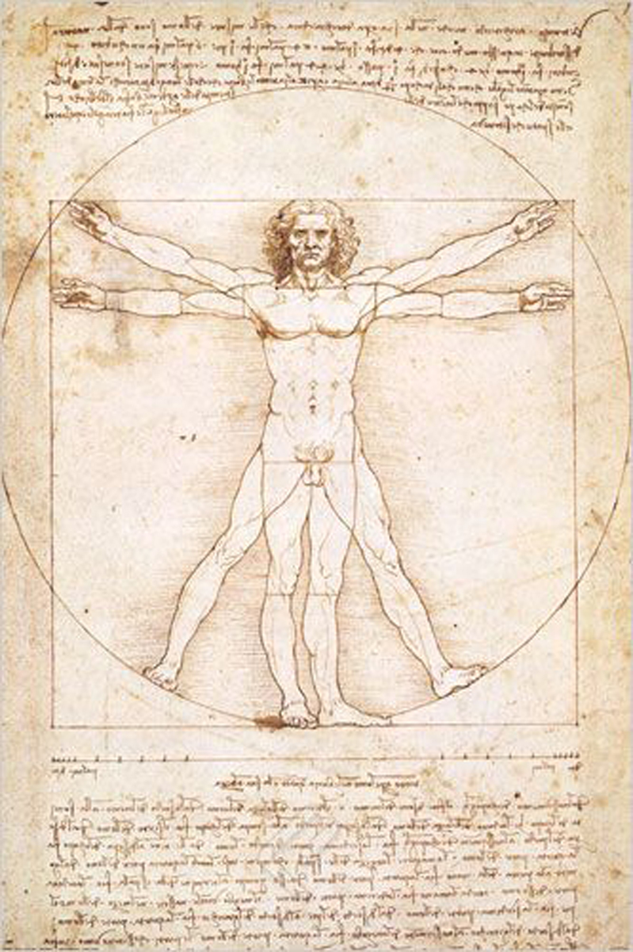 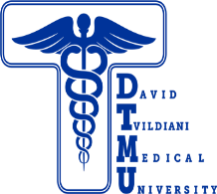

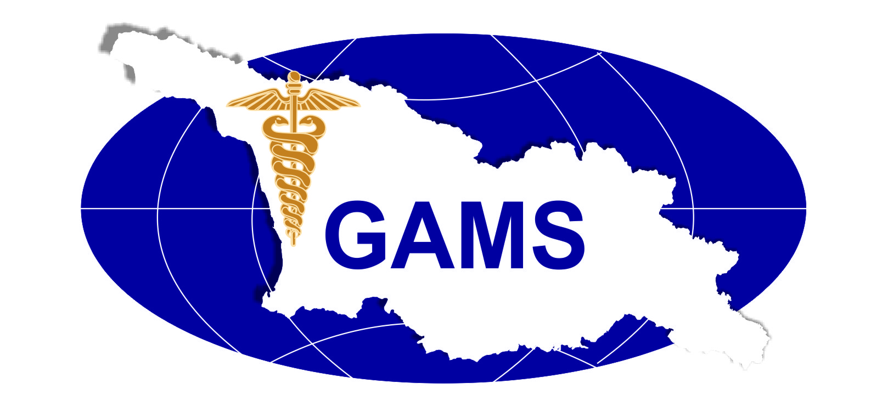

**Georgian Association of Medical Specialties (GAMS)VII International Hybrid Conference “Management of Cognitive Disorders and Pain in the Era of Evidence-Based and Personalized Medicine” November 19, 2022 Telavi, Kakheti, Georgia**

**PLATINUM**

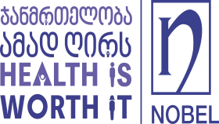 

**GOLD**



**SILVER**

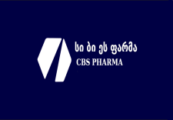

**BRONZE**

* 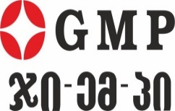  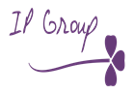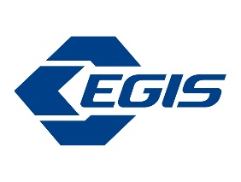*

Supporter of the Event **Berlinhemi**